

**FML IT**

**CIO Report**

**October 2023**

|  |  |
| --- | --- |
| Author: | Candice Govender |
| Date finalized: |  |
| Document version: | 0.1 |
| Document status: | Draft |
| Document file name: | FML IT CIO Report |

Contents

1. Executive Summary 3

2. Systems Uptime 3

3. IT Incident and Service Management 4

3.1 Incidents Resolution 4

3.2 Month on Month Incident Report 5

3.3 Incident Age Analysis 5

3.4 Incident and Service Management commentary 6

4. Transaction Stats 7

5. IT Infrastructure and Software Management 8

5.1 Unsupported Technology 8

5.2 Upgrade Roadmap 8

5.3 Batch Monitoring 9

6. Capacity View 10

6.1 Business Analysis 10

6.2 Development 10

6.3 Quality Assurance 10

7. FML PMO Overview 12

8. Business Delivery 17

8.1 Initiatives in Progress 17

8.2 Initiatives Deployed 17

8.3 Total Deployments per Classification 18

8.4 Sofico Service Desk 20

9. Quality Assurance 21

10. HR 22

11. IT Risk 23

12. Security 26

13. Finance 28

14. General 29

15. Distribution 30

# Executive Summary

[To be updated] The much-anticipated go-live of M3 took place in July over 2 weekends. The code deployment of enhancements and changes made after the Upgrade over the weekend 14- 17th July, followed by the RT46 Data Migration and verification over 21st – 24th July. As anticipated, we were in high-care and the programme carefully tracked and prioritized urgent issues and there speedy resolution thereof. We will be in high-care till September. Production Incidents which had been worked on, and had been on hold due to the M3 freeze, had been deployed and emphasis is now on the Sofico Mitigation.

# Systems Uptime

* 1. Systems Uptime

Overall, we had an average uptime of 99.86%

For the Month of October, WesBank experienced two severity one outage (FNB Reportable), and no severity two outages, and one severity three notable outages (it must be noted that the severity three outage was intermittently unavailable).

**Figure 4: Systems Uptime – WesBank Applications (Data labels reflected where uptime less than 100%)**

**Figure 5: Systems Uptime – FNB/Vendor Applications (Data labels reflected where uptime less than 100%)**

**Figure 6: Systems Uptime – Reporting Applications (Data labels reflected where uptime less than 100%)**

**Figure 7: Systems Uptime – E-Business Suite (Data labels reflected where uptime less than 100%)**

# IT Incident and Service Management

## Incidents Resolution

| **Date** | **Incident** | **Business Impact** | **Root Cause** | **Remediation** | **Preventative Measures** | **Incident Classification/Duration** |
| --- | --- | --- | --- | --- | --- | --- |
| AUTOCARD | | | | | | |
| 10/10/2023 | **INC6247655 – Autocard** multiple, file failure  from **07h00** to **09h44** | This resulted in Autocard front end not being available, until the service restored. | Custody BaNCS experienced multiple batch failures in production where an error message ("CannotCreateTransactionException: Connection is not available") was observed.  Root cause has not yet been identified, and it will be investigated via the problem ticket with I&SS Open Systems Storage SAN and the vendor (DataScience). | I&SS Open Systems Storage SAN was advised by the vendor (Data Science) to perform a failover for the affected controller.  After the controller failover was completed successfully, all services were restored, and the business confirmed operations at 09:20. | No preventative measures have been identified at this point and will be determined once the problem investigation has concluded. | P1 high  Nr of incidents = 1  All incidents closed.  Cumulative duration of minutes 2 hours 44 minutes  FNB reportable outage |
| FINTEGRATE | | | | | | |
| 23-24/10/2023 | **INC6315133** –  **Fintegrate**, currently unavailable, from 07h00 to 17h30 | This resulted in Debit orders and Payments needing urgent intervention and a near miss event being logged by business: Issue Rating – Acceptable  As there was no impact. | One specific client, DC Partner (EQ737E) in SA, sent through the same file multiple times, which created a massive backlog of about 42000 file transfer requests.  The client indicated that they had done an upgrade on the Webserver that connects to the Bank, this server was up and running, the previous server was however inadvertently started up thereby resulting in 2 instances of the same process running each of which then processed the transactions that needed to be sent to the bank, the issue was only picked up when they were advised that duplicate transactions were being sent to the bank. At which time the duplicate instance was stopped.  While this issue persisted on the client side, the internet server was running at its maximum throughput, processing 500 file requests per minute, which is the MFT limitation. This resulted in a massive backlog (42000 at 09:30am) in Fintegrate and the underlying file service component (FILESRV) in the integration layer, resulting in more than 6 hours of delay in processing file transfers. | The client causing the issues was temporarily disabled to stop incoming traffic.  Support performed a stop and restart of the File Server box to give any sort of reprieve and get the files to process quicker.  After the stop and restart, there was an improvement in the file processing; however, after some time, a slight performance degradation was observed in the environment.  Integrations Layer Support developed an app to remove DC Partner files from the processing queue and deployed it to aid in the processing of non-DC Partner files. | CRP B2B DEV Support will consider the following choices in order to avoid future occurrences.  - Investigate the splitting the FILESRV Instances for fast tracking of high priority processing. - Integrations Layer  - Monitoring / Reporting - Integrations Layer and Fin1 Team (File size / Transactions)  - Early identification of issues based on client behaviour. (To be investigated)  - Validation Checks of submitted files at entry point  - Operating Support Model - RMB Production Support (RACI)  - Support created a mini app to clear duplicates (The app reads from the same file that the server is reading.)  - Validation Checks of submitted files at entry point.  - Throttle misbehaving clients.  Splitting of incoming and outgoing files into separate volumes  -Tibco MFT Concurrency  - Operating Support Model: RMB Production Support  - RACI  - Retain the mini app that was created by IL to extract messages for bad-acting clients.  - Discussion with the client with regards to their interactions with the bank 1 file containing, on average, 5 transactions.  - Meeting with the Fin2 team to understand the architecture and design for Fin2  - File transfer changes moving files between the different servers, bypassing FILESRV to be investigated.  - Traffic throttling: back pressure with prioritization  - Round-robin transactions: scheduling was TBC | P1 high  Nr of incidents = 1  All incidents closed.  Cumulative duration of 3 hours 71 mins  RMB reportable outage |
| **TELKOM** | | | | | | |
| 19/10/2023 | **INC6294202** – **Telephone** lines unavailable, on certain ranges, IT investigating | This resulted in intermittent call disconnects on certain ranges. | On Vodacom ranges calls were disconnecting intermittently, root cause unknown | Error, it resolved itself, and the number ranges that were tested worked | Unknown as this error seemed to be specific to the SP and not internally as we experienced a similar error when using a MTN cell phone to contact the Vodacom number ranges as a test. | P3 high  Nr of incidents = 1  All incidents closed.  Notable |

## Month on Month Incident Report

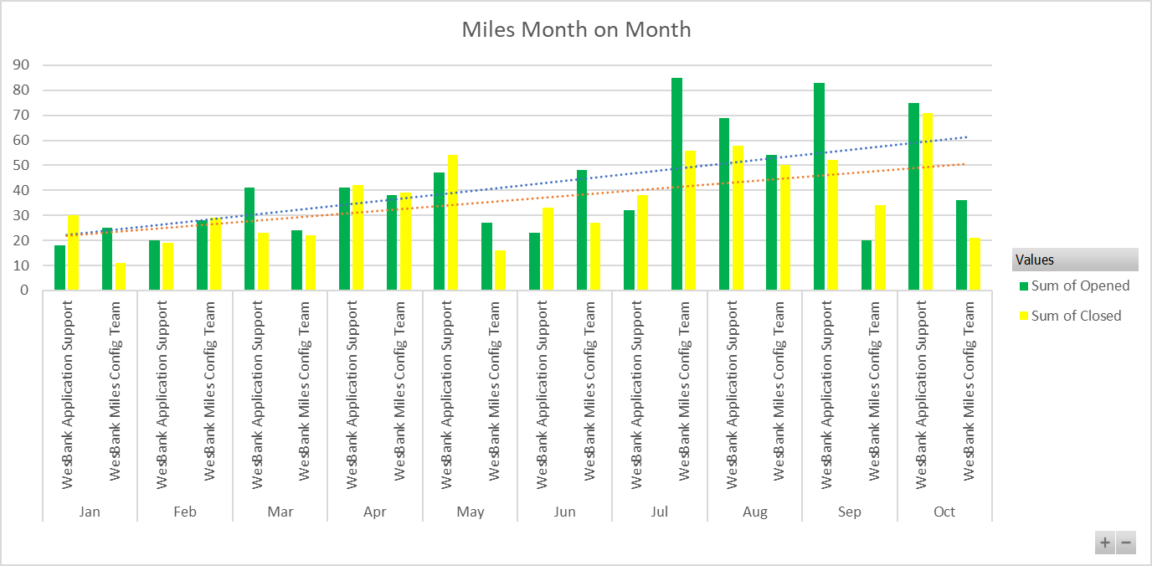

**Commentary:**

There has been an increase in the number of incidents due to business user roles changes after release deployments. A number of refinements and changes into the current process of working has come into the area for Config & Dev team. Training issues still remain within business as incidents raised are closed within the application support area providing clarity and guidance to business on how to utilize the functions in the application

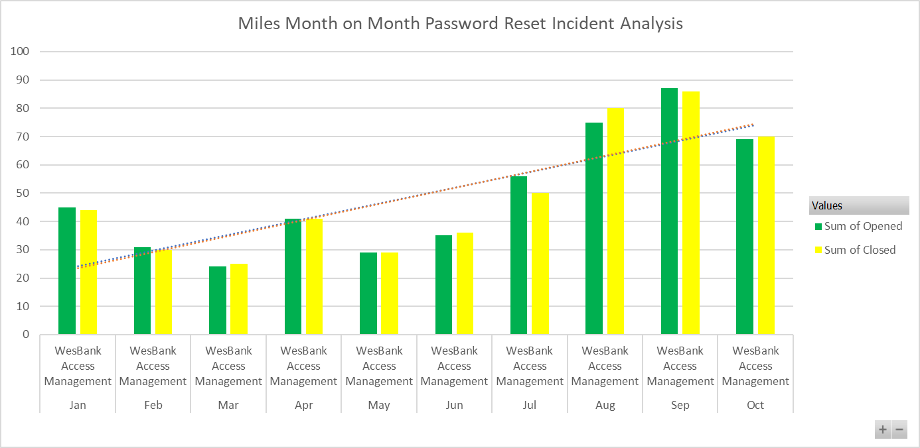

**Commentary:**

## Incident Age Analysis

|  |  |  |  |  |  |  |
| --- | --- | --- | --- | --- | --- | --- |
| **Number of Open Incident Age Analysis** | | | | | | |
| **Month** | **Sum of current** | **Sum of 31-60 Days** | **Sum of 61-90 Days** | **Sum of 91-120 Days** | **Sum of >120 Days** | **Sum of Total** |
| 23-Sep | 64 | 74 | 24 | 9 | 27 | 198 |
| 23-Oct | 67 | 49 | 63 | 22 | 39 | 240 |

**Commentary:**

## Incident and Service Management commentary

**Successes:**

* FNB team has completed the **password** synchronization across on all systems applications occur without different teams' involvement and the user not having to interact with different IT teams. This ensures that users use the same login details to log in to AD, VPN and Autocard. This will no longer be monitored by Service Management Office; this has been streamlined and no escalations have been observed stemming from process flaws.
* There had been a recurring issue whereby **Miles** was hanging. IT held several engagements with business after it was found that some of the attributes to the issue were that when business was requesting reports, the way they ran some reports was causing load on the systems and IT recommended that some reports be automated, or certain selections within these reports be put in place so that these reports do not pull a lot of unnecessary data continuously. This continues to be tracked by Service Management Office as IT had engaged with business super users to be first line troubleshooters (in terms of checking if a report can be pulled with less search criteria) before an issue is raised with IT. Business needed to go and decide on which reports should be automated.

**Challenges:**

* There have been numerous issues being experienced on **Miles** that an official problem statement has been raised and these will continue to be tracked as one problem statement for the FNB Problem Management team for resolution however being attended to by the Miles Development team. There are also ongoing discussions and meetings for the team to understand and streamline standard operating procedures for Incidents, Problems and Changes. This will continue to be monitored by Service Management Office.
* ACB payment failure on **Miles** with impact of 556 supplier payments worth R 13,039,656.41 could not be processed. The root cause was found to be that after the export file was sent to Oracle for processing, a PVR file came back with an error and reversed the payments on Miles. Upon investigation, it was identified that there was a mandatory invoice address that was missing for one supplier. The preventative measure was put in place after the resolution that a selection needs to be created for business to view all mandatory fields on **Miles** for **ACB payments**. This can be used at any time.
* Another failure on **Miles** occurred of a debit order failure whereby 87 customers could not be debited for the value of R 1,535,305.96. The system gave an invalid error (Fiscal Period Closed) when the hashfile was being processed from Fintegrate which was found ot be the root cause. The following were found ot be the root cause that an investigation needs to be conducted on what could be causing the invalid error at the beginning of each month and then thereafter put mitigations in place (Config team/Sofico), as well as a technical discussion needs to be held with the IT ops team, to confirm how the technical permission delays that were experienced can be avoided going forward.
* There was an issue whereby some **LAN points** were not working due to a software related issue on a switch, which was escalated to an external vendor, CISCO for troubleshooting. This occurred on Friday which was not a busy day for business and management allowed users to connect to 3g dongles in the office as wifi was also impacted due to congestion of most users being on the wifi while these **LAN points** were investigated. Issue was resolved over the weekend.
* The issue for **ImageNow** is proactively being monitored for the large sizes of mailboxes. The investigating team has created a rule on these mailboxes that will either move the large emails out of the Inbox and into a separate folder or forward the mail to someone in business so that it can manually be captured into ImageNow. The outstanding task is for business to provide people that the rule will send these large emails to that will be captured manually. This will be tracked by Service Management Office. The issue resurfaced however IT proactively intervened as names are still not received from business.
* There was a high severity failure experienced across First Rand Group to the FML Business the impact was that **Autocard** was down. The root cause remains unknown however the failure was escalated to the vendor. Part of their resolution was that the team had to perform a failover for the affected controller. And post the controller failover was completed successfully, all services were restored, and the business confirmed operations.

## Problems

**Tracking of Problem Statements and number of days open**

| **Date** | **Problem** | **Business Impact** | **Root Cause** | **Remediation** | **Preventative Measures** | **Incident Classification/Duration** |
| --- | --- | --- | --- | --- | --- | --- |
|  | | | | | | |
| 2023-01-24 /2023-08-03-Ongoing | **PRB0046248 –**  **Miles hanging errors** | Since inception of the application, various users experience timeouts on certain functions within the application | Additional fields that are added on the Miles application as a result of releases being implemented on the application are causing locks on the Database, an example would be due date field on the purchase invoice, selections are causing the application to go in a hung state.  There are various scenarios to be investigated with the vendor. | Investigations are underway with the Vendor, the task is being tracked and updated when these fixes are being presented.  There are various workarounds in place with the config team and business and as a result the problem will remain open until all these scenarios have been resolved. | Will be completed once all issues have been resolved (suggestion, all issues be documented and a definitive media library be created with the assistance of risk). | P4 Low/Urgency  All incidents closed.  Reactive  FNB reportable outage |

**Tracking of Problem Statements and number of days open**

**Noteworthy:** The Problem Management has moved into FNB ISS team, these problems are now tracked from there with weekly meetings with the technical teams.

* **549 Days - Implementing FNB SIP trunk for redundancy on WesBank voice lines:** 
  + During a WesBank Telkom PRI voice line failure, WesBank is unable to route calls in an alternative manner. Depending on the nature of the failure it could result in these lines being down for an extensive amount of time and the affect is that our contact centers are unable to make and receive calls.
  + IT CIC Team installed BCX SIP trunk with full redundancy. However, FRG is unable to control what could possibly happen on last mile infrastructure.
  + The FNB SIP trunk is in place however the extension charge out is not. This has an impact on the IT Finance due to CDR pointing to FNB however Wesbank is paying for every incoming on smart access and toll-free calls pointed to the FNB SIP trunk**.**

**Risks**

* The risk that involves some CIC interventions (for all interactions happening on CIC (this includes telephony services, emails and attachments interactions to have a unique caller identity) so that FML business meets regulatory and compliance standards. Since there are development costs involved FML business will need to log RFS (Request For Service) and a project manager be assigned to facilitate this.

**IT Environmental Changes**

* + FNB Linux Server Patching IT Maintenance slot 07-10-2023 2pm-10pm Miles will be down from 6pm, ImageNow down from 2pm
  + WesBank Planned Windows Server and Third-Party Patching 07/08-10-2023 CIC no down impact, queueing might be affected
  + Miles Production log rotation& flush strategy configuration 22/10/2023 2pm-6pm Miles will be down only between 530pm&6pm

# Transaction Stats

No Update received

# IT Infrastructure and Software Management

## Unsupported Technology

The following software is currently outdated and/or unsupported:

* + FROG Stack: The FROG software stack which includes, OBIEE, OFSAA, Hyperion, ODI, Infogix and Informatica needs to be upgraded as most of these platforms have reached end of support.
  + The project is progressing well, and we have reached the performance testing stage with all previous testing and concerns being resolved.
  + Hyperion and Infogix upgrade completed
  + OC4j 10G for BI: The Oracle software is outdated and unsupported. A migration to Power BI is currently in progress and the completion date is currently 24 to 36 months.
  + 2 x FleetActiv Servers: Servers were rolled back to Server 2008 R2 as part of the agreed process to halt the upgrade in favor of Miles replacement. A suitable date to decommission these environments are currently under investigation with and estimate been given for November 2025.
  + 1 x SharePoint Server: CWF is being tested on Server 2012 in QA. Compatibility problems with the sites are under investigation in QA.

## Unsupported Hardware

|  |  |
| --- | --- |
| **Application** | **Progress** |
| MegaFTP | The MegaFTP environment is extremely old and no connections can be made to a 19c database.  On SPIF a work around has been put in place to use the functionality of an Oracle 11g database to enable functionality on MegaFTP. This is a temporary solution as the Oracle 11g database will not be supported after 31 December 2020. |

## Upgrade Roadmap

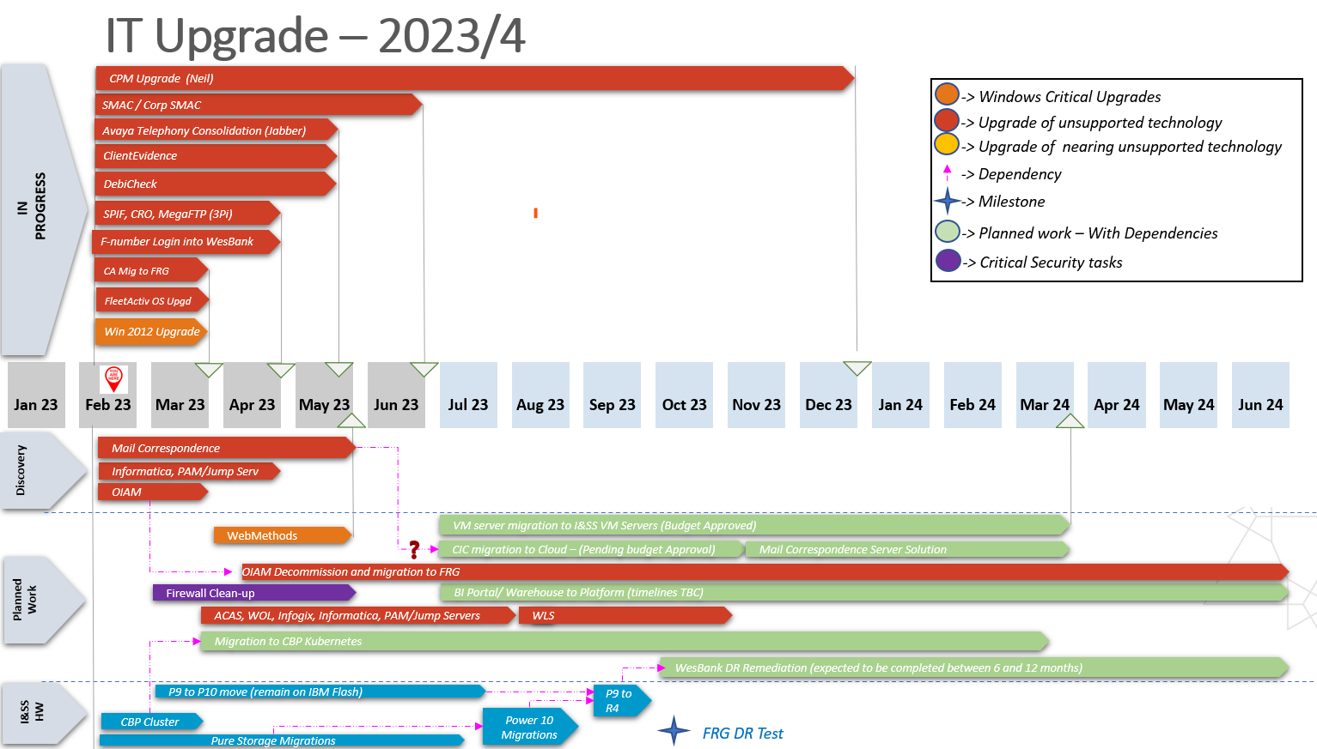

* Client Evidence – During the performance testing phase it was decided that the upgrade planned for May 2023 will be postponed to July 2023 to ensure all concerns can be alleviated and enough time can be given to all teams to correct the concerns.
* Fleetactiv currently on Windows 2008 and being tested on Windows 2019. Migration date currently estimated for October 2023 (best effort August 2023)
* SPIF upgrade – A new date for the upgrade is under investigation
* Pure storage and IBM P10 migration – Project to plan and start migration to the IBM P10 have been started.
* The Red 3 production/DR environment migration initially planned for the weekend of the 16th to 18th of June was postponed due to instability and performance concerns. Investigations with the vendors were conducted and minor environment configuration changes and data refresh was conducted which ensured that the stability and performance concerns were alleviated.
* New dates for the move to the P10s are being planned for the months of October and November 2023.

## 5.3 Batch Monitoring

The following Miles jobs fail every weekday and notification of errors was sent to business, as these errors are related to data, and Business involvement is required to rectify the data on the system.

**Stopped with Errors**

|  |  |
| --- | --- |
| Job name | Status |
| CRO Locate Supplier | Stopped with Business Error |
| CRO Fetch KYC Customer | Stopped with Business Error |
| CRO Locate Customer | Stopped with Business Error |
| Auto Take in vehicle for ET - Written Off | Stopped With System: TakenVehicle 5012578 Error Since the vehicle is not in use it cannot be taken in. |
| Set Telematics TPSC provider | Ended with Business Error |
| SU Tyre fund suspense clearing | Stopped With System Error |
| SU Maintenance fund suspense clearing | Stopped With System Error |
| SU TAX Vehicle Sales Cost Posting | Stopped With System Error |
| SU ACC Vehicle Sales Cost Posting | Stopped With System Error |
| Send Email to Suppliers where BBB EE is expiring in 1 month | Stopped With System Error |
| Send Email to Suppliers where BBB EE is expiring in 2 month | Stopped With System Error |
| Send Email to Suppliers where BBB EE is expiring in 3 month | Stopped With System Error |
| WBSA_DirectDebit_LoadReport_Import | Stopped With System Error |
| WBSA_Direct_Debit_Export | Stopped With System Error |
| WBSA_NonVehiclePurchase_Payment_Import | Stopped With System Error |
| Non vehicle purchase invoice payment export - ACB format | Stopped With System Error |
| Import Odometer Readings | Stopped With System Error |
| SMAC Customer Export | Stopped With System Error |

**Ended With Business Error**

|  |  |
| --- | --- |
| Job name | Status |
| Automatic contract closure | Ended With Business Error |
| Charge-back managed maintenance invoicing | Ended With Business Error: The business partner with ID 5710476 is not a customer. |
| Charge back no contract | Ended With Business Error: The business partner with ID 5795355 is not a customer. |
| Generate consolidated invoice - Charge back license | Ended With Business Error: 5796034 Invoice payment information is missing. |
| Perform Distance Settlements after Contract Termination | Ended With Business Error: 5702861 The distance settlement is not allowed. There is already a later distance settlement. |
| Settlement (termination) invoicing | The fiscal period is now closed. Please enter a valid post date/fiscal period or reopen the fiscal period. |
| Renew AA FLEETCARE Roadside Assistance | Ended with Business Error: Failed to process tpsc(s) further. TPSC id(s) = 5017350 with error = 0 |
| Rental invoicing - Monthly - In Arrears - Fleet Managed – Cut off | Stopped with System Error Someone changed the same data in between. Please refresh your data before you save again. |
| Rental invoicing - Monthly - In Arrears - Fleet Managed – Cut off-14 | Ended With Business Error |
| Generate and Send Tax Invoice - Upfront (plan fee OEM) - Non-PO/ Invoice Generation Times | Ended With Business Error: 5005176  5018856,5018858 |
| Generate and Send Tax Invoice - Settlement invoice - Non-PO | Ended With Business Error: Unable to resolve document context 500061; none of the underlying document handlings gave a result. |
| Set RMT Collect and Pay Over TPSC provider | Ended With Business Error 5024743 No solution found for the lookup (lookup table 'RMT Collect & Pay Over suppliers' with id=500089). |
| Validate precomputed amendment quotes (prime interest rate bulk modification) | Stopped With System Error |
| Update Once-Off Supplier Flag | Ended With Business Error |
| Cancel orders that were not invoiced for 3 years and above | Ended With Business Error |

# Capacity View

## Business Analysis

|  |  |  |  |
| --- | --- | --- | --- |
| **Resource Name** | **Role** | **Employment Type** | **Assigned To** |
| Ndivhuwo Mkhabela | Business Analyst | Contractor | - M3 Post Implementation (tracking tickets raised and UAT) |
| Miehleketo Ndlovu | Business Analyst | Contractor | - M3 Production Support  - DBR Job Seats  - Direct Debit & Direct Credit process documents |
| Vikas Kathuria | Business Analyst | Contractor | - M3  - Miles/Autocard Data Integration  - SAPS job card & NSO  - Merchant Connector |
| Mbali Shamu | Business Analyst (DM) | Contractor | - M3 |

## Development

|  |  |  |  |
| --- | --- | --- | --- |
| **Resource Name** | **Role** | **Employment Type** | **Assigned To** |
| Mandla Mthombeni | Developer | Contractor | - Production Support |
| Themba Sivate | Developer | Permanent | - Production Support |
| Nandipha Napakade | Developer | Contractor | - Production Support |
| Nkosinathi Mahlangu | Developer | Permanent | - M3  - Batch Monitoring and Management |
| Sibusiso Ndaba | Developer | Contractor | - M3  - Batch Monitoring and Management |

## Quality Assurance

|  |  |  |  |
| --- | --- | --- | --- |
| **Resource Name** | **Role** | **Employment Type** | **Assigned To** |
| Lindiwe Mhlongo | Senior Test Analyst | Contractor | -M3  -Miles October/November Releases |
| Abel Mphahlele | Test Analyst | Permanent | -M3  -Miles October/November Releases |
| Sandy Naidoo | Test Analyst | Permanent | -Miles Lookup Tables  - FleetActiv Support  -Miles October/November Releases |
| Luvuyo Silwana | UI Test Engineer | Contractor | -M3 Automation Scripting  - Automated Sanity Testing  - Regression Testing |
| Zenzele Jobe | Test Analyst | Contractor | -M3 Post Implementation Support  -Miles October/November Releases |
| Kevin Ndou | API Test Engineer | Contractor | -M3 Integration Testing |
| Nokuthula Ndlangamandla | Test Analyst | Contractor | -M3 Post Implementation Support  -Miles October/November Releases |
| Jongikhaya Tshaka | Test Analyst | Contractor | -M3 Post Implementation Support  -Miles October/November Releases |

## Architecture

|  |  |  |  |
| --- | --- | --- | --- |
| **Resource Name** | **Role** | **Employment Type** | **Assigned To** |
| Johan Stieler | Enterprise Architect | Permanent | - FML (50% allocation) |
| Sekhonyana Molapo | Solution Architect | Permanent | - FML IT (ALL)   * RT46 (SAPS Jobcard & NSO) * M3 * Miles/Autocard Data Integration * Miles LDAP Integration * Documents Repository |

|  |  |  |  |  |  |  |  |  |  |  |  |  |
| --- | --- | --- | --- | --- | --- | --- | --- | --- | --- | --- | --- | --- |
| **No** | **Date** | **Programe Name** | **Project Name** | **Project Priority** | **Process/Task Issue** | **Action Type (Note / Action / Decision)** | **Action Description** | **Action Owner** | **Due Date** | **Comments** | **Status** | **Architect** |
|  |  |  |  |  |  |  |  |  |  |  |  |  |
| 1 | 11-May-23 | M3 & CRO | CRO |  | Technical | Action | CRO - Customer Onbording Portal for Customers | Pravada | TBA | Technical Person is Mayuri  This is corporate migraton for customer | Open | SK |
| 2 | 12-May-23 | M3 | BI Reporting |  | Technical | Action | BI Reporting and Replication DB | Shaun | 15-May | Technical Discussion have had with BI Team  Meeting Set up for 15 May to go through Pros & Cons | Open | SK |
| 3 | 10-May-23 | FML | Customer Portal |  | Technical | Action | Business Requirements for FML Customer Portal | Ayana Gantsu | TBA | The initiative is in the business requirement. | Closed | SK |
| 4 | 15-May-23 | FML | Bulk Licence Renewal |  | Conceptual | Action | Review Connect me requirements and start with Conceptual architecture | Sekhonyana / Johan | 31-May | 15/05 Requirements to be verified. Interact with Hussein Patel | Open | SK |
| 5 | 15-Jun-23 | FML | Miles |  | Conceptual | Action | Cloud vs Inhouse hosting | Sekhonyana / Johan | 30-Oct-23 | Investigate cost and support for Hosting Miles on Sofico Cloud Platform | Open | SK |
| 6 | 15-Aug-23 | FML | Motomatix Proof of Concept |  | Conceptual | Decision | Using data from Motomatix to compare prices on quotations given by Merchants | Linda | TBA | Business has gone ahead to engage the Vendor without consultaion of IT & Architecture | Open | SK |
| 7 | 15-Jul-23 | FML | SAP JobCard and NSO |  | Technical | Action | Defining New Process for SAPS JobCards and NSO | Derrick | 15-Sep-23 | Specification for this process is still being finalised and requirements signed off | Open | SK |
| 8 | 16 Jul 23 | FML | Tracker -Fleet Tracking Automation |  | Conceptual | Action | Automation of the Vehicle Tracking Activation for FML | Aneesa | TBA | Prior engagement has been had with business and the vendor (Tracker) to determine highlevel process | Open | SK |
| 9 | 31 Oct 23 | FML | Miles Off Server Storage |  | Technical | Action | Solution for Miles Off Server Storage | Gerhard | 30 Nov 23 | Engagement have been had with Sofico do determine best interim Solution | Open | Sk |
| 10 | 31 Oct 23 | FML | Miles Integration View |  | Technical | Action | Document Current Miles integration and components | Gerhard | 30 Nov 23 | A 1st draft of this view has been documented | Open | SK |

# FML PMO Overview

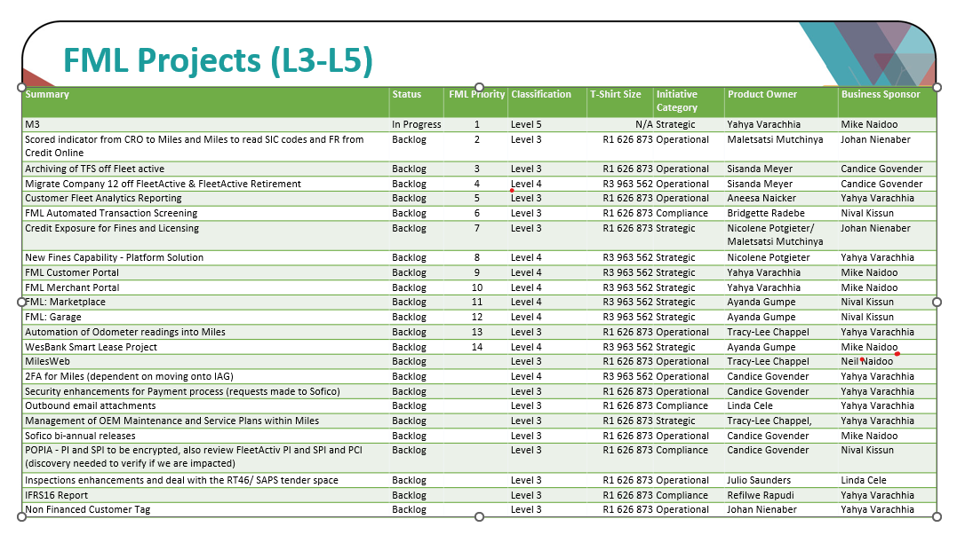

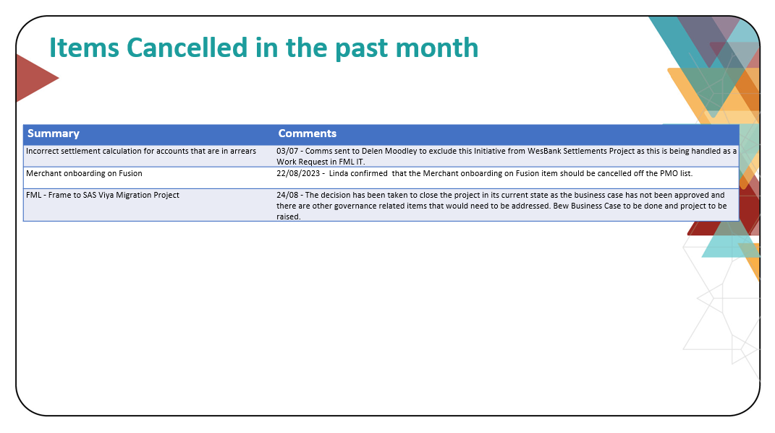

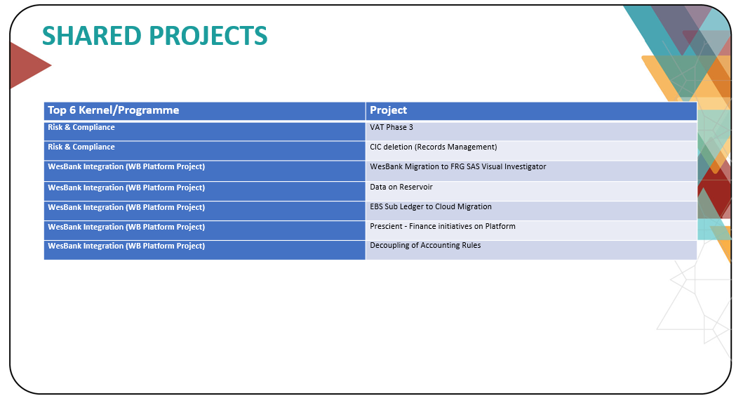

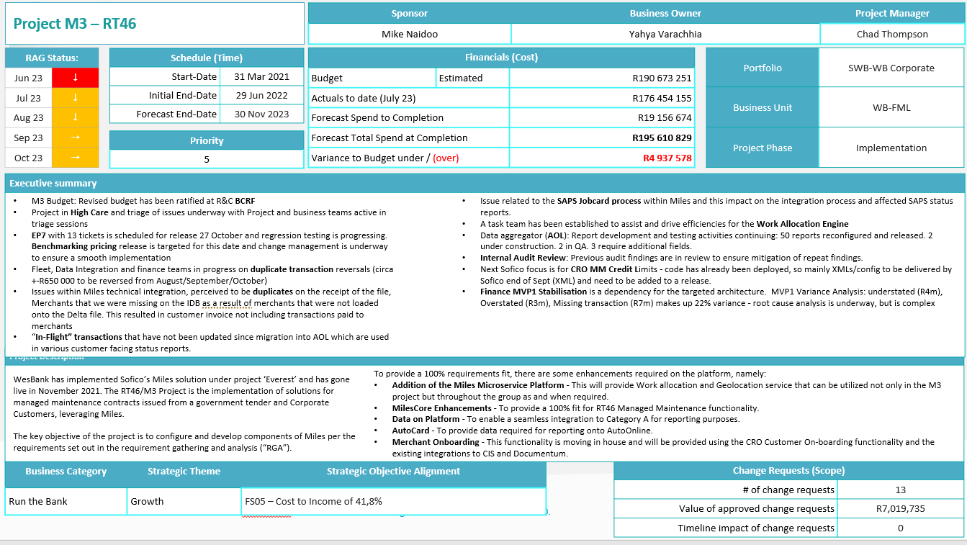

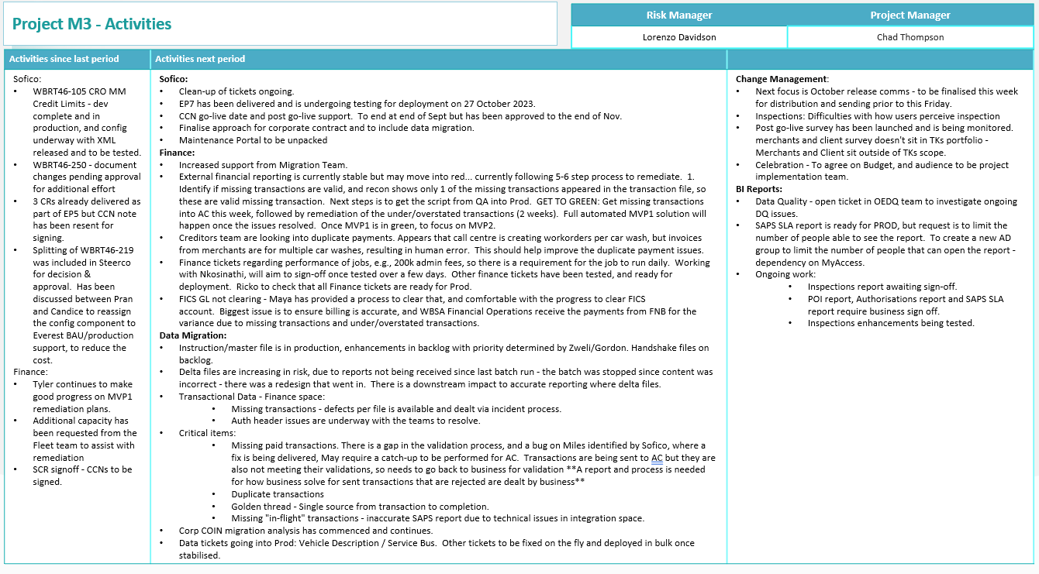

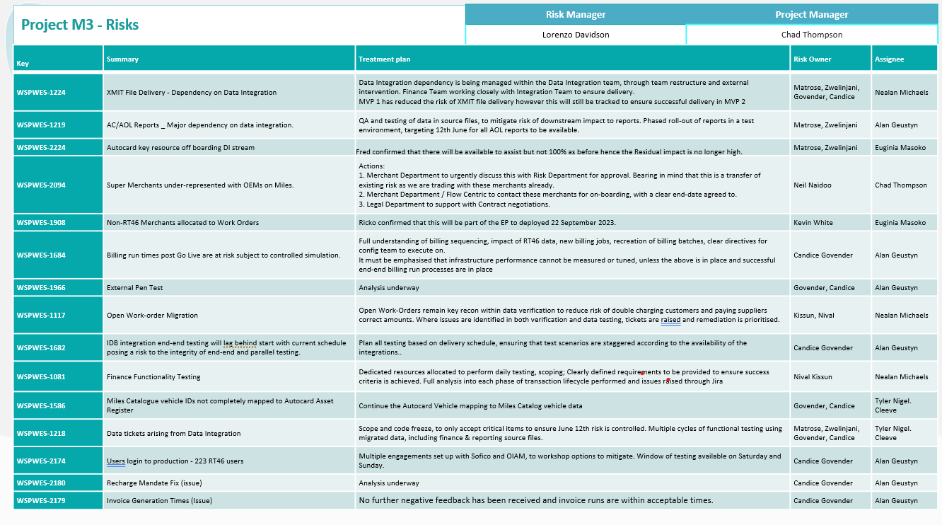

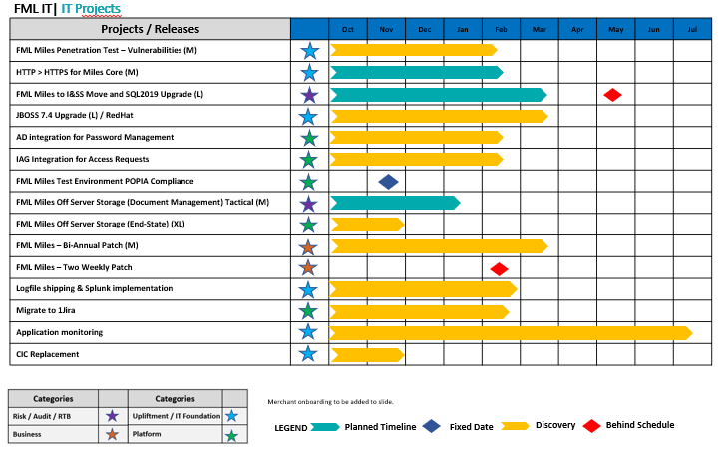

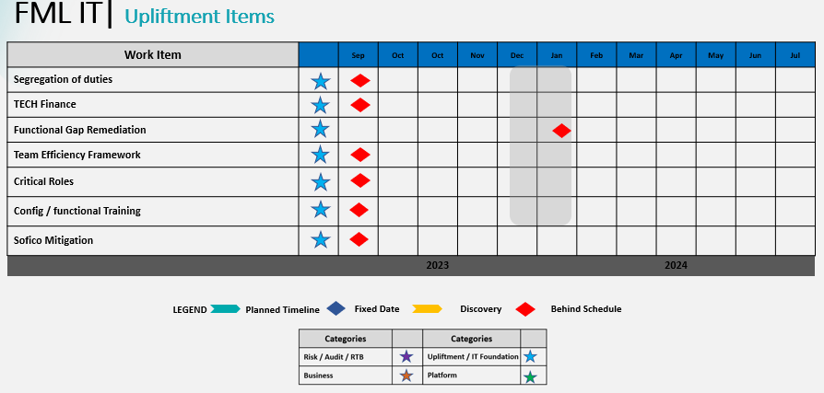

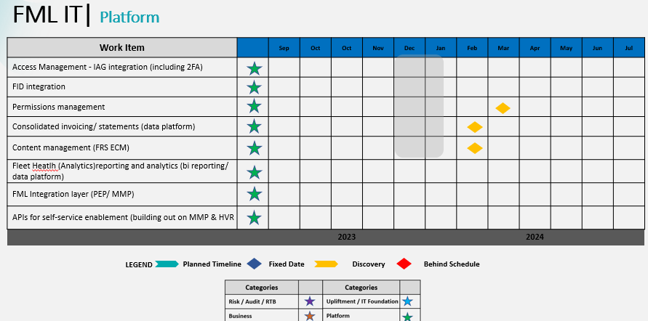

# Business Delivery

## Initiatives in Progress

|  |  |  |  |  |
| --- | --- | --- | --- | --- |
| Start Date | Release Date | Status / Phase | Request | System |
| Work Requests | | | | |
|  | 10/11/2023 | Testing | Incorrect settlement calculation for accounts that are in arrears | Miles |
|  | 10/11/2023 | Testing | SAPS Jobcard file Enhancement | Miles |
|  |  |  |  |  |
| Business Projects | | | | |
|  | 17/07/2023 | Post Implementation Support | M3 Implementation | Miles |
|  | TBC | On-hold | Miles Web Portal | Miles |
| IT4IT Projects | | | | |
|  | 15/09/2023 | Implemented | FleetActiv Migration to Windows 2019 | FleetActiv |

## Initiatives Deployed

|  |  |  |  |  |
| --- | --- | --- | --- | --- |
| Start Date | Release Date | Status / Phase | Request | System |
| Work Requests | | | | |
|  | 13/10/2023 | Implemented | [M3 Prod - RT46 RMT Administrator Role can Edit Distance Registration](https://sofico.atlassian.net/browse/WBM3QA-1152) | Miles |
|  | 13/10/2023 | Implemented | Chargebacks for purchase invoices that were posted after the “Update VAT Code to STDZ on Charge-on BI linked to Non Vat Liable Suppliers” had already run had the incorrect VAT posting code resulting in VAT being added to non-VAT liable invoices due to the “Charge-back invoicing” job picked up the invoices and applied the incorrect invoice type to the sales invoice. | Miles |
|  | 13/10/2023 | Implemented | M3 Prod- Merchants Department- Inability to remove a competency from the lookup table | Miles |
|  | 13/10/2023 | Implemented | Performance improvement for “Dispute and Credit Outgoing Invoice RT46 SAPS Monthly Rental” job | Miles |
|  | 13/10/2023 | Implemented | M3 Prod- Merchants - Remove ability to approve on Early Settlement Lookup Table | Miles |
|  | 13/10/2023 | Implemented | Miles Direct Debit Load Report Import error | Miles |
|  | 13/10/2023 | Implemented | M3 Prod - There is no way to distinguish between Cost Centre and Sites when link a new Contact as an RMT User on SAPS | Miles |
|  | 13/10/2023 | Implemented | M3 PROD - ADDTIONAL FIELDS ON THE "INSPECTION REPORTS READY FOR REVIEW" | Miles |
|  | 13/10/2023 | Implemented | NPS - incorrect Net Rental Compensation billing item | Miles |
|  | 13/10/2023 | Implemented | Merchants' Administrator & Supervisor/ RMT Administrator/ RMT Inspector Supervisor/ Finance Executive roles changes | Miles |
|  | 13/10/2023 | Implemented | Add "Customer Name" and "Customer License Plate" to GL: Browse Allocations Selection and Results | Miles |
|  | 13/10/2023 | Implemented | TPSC: Units Not Pulling Into Renewal | Miles |
|  | 13/10/2023 | Implemented | Shoprite Checkers Miles Cost Centres Duplicated | Miles |
|  | 13/10/2023 | Implemented | Incorrect contract link to FV and business does not have the minus(-) button to remove it. Please remove LTC 5024084 as per the screen prints. | Miles |
|  | 13/10/2023 | Implemented | Why can Finance Administrator - AR make changes to the payment file. | Miles |
|  | 13/10/2023 | Implemented | Activation type for sales admin role | Miles |
|  | 13/10/2023 | Implemented | My team is getting an error when attempting to approve a Generic Order | Miles |
|  | 13/10/2023 | Implemented | unable to terminate vehicle - JH43XVGP | Miles |

## Total Deployments per Classification

{input of graph for changes per classification – Change Control}

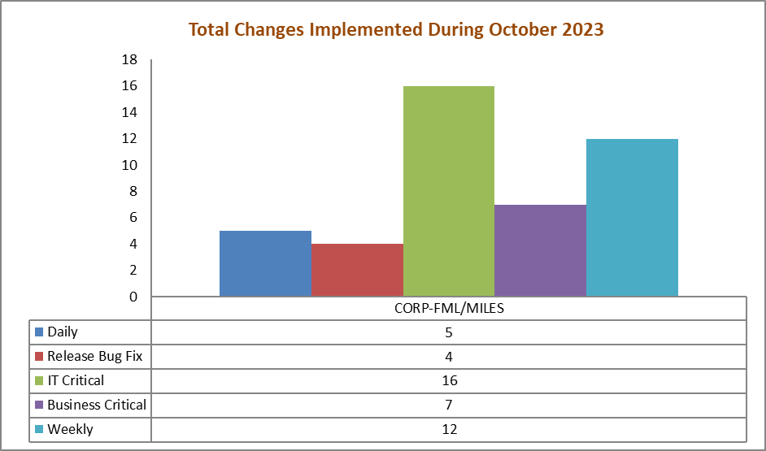

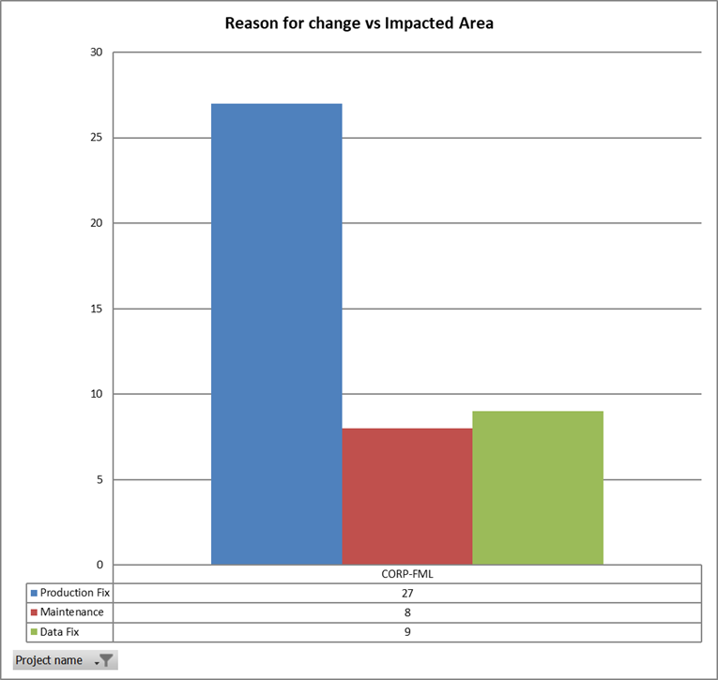

|  |  |  |  |  |  |
| --- | --- | --- | --- | --- | --- |
| **Issue key** | **Planned Release Date** | **Summary** | **Work Type** | **SN Incident I.D** | **Release Category** |
| FML-5269 | 2023/10/13 13:33 | ACB uatomation | Maintenance | INC6223650 | Daily |
| FML-5233 | 2023/10/03 12:15 | Incorrect vehicle description - 20231002 | Data Fix |  | Daily |
| FML-5253 | 2023/10/06 10:30 | Incorrect vehicle description - 20231005 | Data Fix |  | Daily |
| FML-5287 | 2023/10/10 14:00 | Incorrect vehicle description - 20231010 | Data Fix |  | Daily |
| FML-5296 | 2023/10/10 14:00 | WBM3QA-1070UpdateSysMessage | Data Fix |  | Daily |
| FML-5069 | 2023/10/13 06:00 | M3-WBM3QA-1135 | Maintenance | INC6060649 | Weekly |
| FML-4523 | 2023/10/13 13:30 | Miles Selection 501613 is displaying a fluctuating quantity of Book Values and differing values on different days | Maintenance | INC5638408 | Weekly |
| FML-5308 | 2023/10/13 13:42 | M3 Add "Customer Name" and "Customer License Plate" to GL: Browse Allocations Selection and Results | Maintenance | INC6248145 | Weekly |
| FML-4989 | 2023/10/13 18:00 | M3 Prod -WBM3QA-1152 RT46 RMT Administrator Role can Edit Distance Registration | Maintenance | INC5981548 | Weekly |
| FML-5282 | 2023/10/13 18:00 | M3-Performance improvement for "Dispute and Credit Outgoing Invoice RT46 SAPS Monthly Rental" job | Maintenance | INC6173504 | Weekly |
| FML-5295 | 2023/10/13 18:00 | M3 Prod - The call center team requires more fields on the â€œInspection reports ready for review dashboard.â€ The required fields will be as per below, Please advise if | Maintenance | INC6245810 | Weekly |
| FML-5301 | 2023/10/13 18:00 | M3 Prod - WBM3QA-1188 - There is no way to distinguish between Cost Centre and Sites when link a new Contact as an RMT User on SAPS | Maintenance | INC6249926 | Weekly |
| FML-5222 | 2023/10/13 13:40 | BAU -The activation type on Miles is greyed out | Production Fix | INC6179876 | Weekly |
| FML-4938 | 2023/10/13 13:41 | BAU-All sales administrators do not have access to validate FML quotes. | Production Fix | INC5872146 | Weekly |
| FML-5243 | 2023/10/13 13:41 | BAU-My team is getting an error when attempting to approve a Generic Order | Production Fix | INC6206159 | Weekly |
| FML-5246 | 2023/10/13 13:41 | BAU-Unable to Terminate Vehicle - JH43XVGP | Production Fix | INC6197049 | Weekly |
| FML-4443 | 2023/10/13 13:46 | Shoprite Checkers Miles Cost Centres Duplicated | Production Fix | INC5540475 | Weekly |
| FML-5235 | 2023/10/05 10:30 | Activate Terminated Contracts | Data Fix |  | Business Critical |
| FML-5236 | 2023/10/05 13:46 | Update billing items | Data Fix |  | Business Critical |
| FML-5297 | 2023/10/11 15:30 | Update billing items | Data Fix |  | Business Critical |
| FML-5286 | 2023/10/11 13:00 | Re-activate terminated contracts 20231010 | Data Fix |  | Business Critical |
| FML-5186 | 2023/10/27 13:00 | TRANSACTIONS - Duplicate Transactions (WBM3QA - 1181) | Data Fix |  | Business Critical |
| FML-4084 | 2023/10/13 13:18 | BAU-TPSC: Units Not Pulling Into Renewal | Production Fix | INC5161027 | Business Critical |
| FML-4894 | 2023/10/13 13:19 | BAU-Why can Finance Administrator - AR make changes to the payment file. | Production Fix | INC5909215 | Business Critical |
| FML-5000 | 2023/10/13 13:20 | Incorrect contract link to FV and business does not have the minus(-) button to remove it. Please remove LTC 5024084 as per the screen prints. | Production Fix | INC5830210 | IT Critical |
| FML-5056 | 2023/10/27 18:00 | M3-WBM3QA-1093Â -M3 Prod - Mandate lookup Table using Total Amount Excluding VAT instead of +VAT - CCN (EP5) | Production Fix | INC6060807 | IT Critical |
| FML-5058 | 2023/10/27 18:00 | Benchmark pricing to pull per make and model | Production Fix | INC6060778 | IT Critical |
| FML-4668 | 2023/10/27 18:30 | EP:Please investigate why Deals 5025463 & 5025473 for RCL FOODS CONSUMER (PTY)LTD (5000502) increased. | Production Fix | INC5811819 | IT Critical |
| FML-4992 | 2023/10/27 18:30 | EP - M3 - Prod - User overriding WAE asigned supplier | Production Fix | INC5968987 | IT Critical |
| FML-5261 | 2023/10/27 18:30 | EP - M3 Prod- Merchants- Soft block status functionality hard blocking payments and WO processing | Production Fix | INC6216728 | IT Critical |
| FML-5384 | 2023/10/27 18:30 | EP - ACB Miles Prod | Production Fix | INC6302108 | IT Critical |
| FML-5385 | 2023/10/27 18:00 | M3 Prod WBM3QA-1203 M3 Prod - Automation on "invite to supplier" for accidents | Production Fix | INC6301302 | IT Critical |
| FML-5386 | 2023/10/27 18:00 | EP - M3 Prod WBM3QA-1209 Defaulting incorrect catalog part for vehicle part when no catalog part found | Production Fix | INC6301241 | IT Critical |
| FML-5398 | 2023/10/27 18:00 | M3 Prod - WBM3QA-1226 Recharge Amount is not being updated when Part Price is changed. | Production Fix | INC6316916 | IT Critical |
| FML-5400 | 2023/10/27 18:00 | Miles allowing user role 'Tech advisor FML' to approve accidents | Production Fix | INC6317394 | IT Critical |
| FML-5401 | 2023/10/27 18:00 | EP - Support M3-WBM3QA-1062 | Production Fix | INC6060785 | IT Critical |
| FML-5102 | 2023/10/27 18:30 | EP - Unable to Activate Shoprite Restructures - Amort Tables Not Calculating Properly | Production Fix | INC6093863 | IT Critical |
| FML-5383 | 2023/10/27 18:30 | EP - Miles hanging | Production Fix | INC6301465 | IT Critical |
| FML-5399 | 2023/10/27 18:30 | EP - M3 Prod - WBM3QA-1229 WO status not changing after sending approval documents to Supplier | Production Fix | INC6316924 | IT Critical |
| FML-5419 | 2023/10/27 18:30 | Production Miles Load Report | Production Fix | INC6332899 | IT Critical |
| FML-5218 | 2023/10/04 18:00 | M3 Prod - Clearance Document not pulling in the correct Email Contacts from Customers (eg. SAPS) | Production Fix | INC6178396 | Release Bug Fix |
| FML-5152 | 2023/10/13 13:40 | Miles Roles Fixes | Production Fix | INC6120171 | Release Bug Fix |
| FML-5337 | 2023/10/18 18:00 | Sales administrators are missing a calculation button | Production Fix | INC6275392 | Release Bug Fix |
| FML-5357 | 2023/10/18 18:00 | Procurement administrative role access | Production Fix | INC6283857 | Release Bug Fix |

## Sofico Service Desk

1. Ticket Statuses - YTD by month

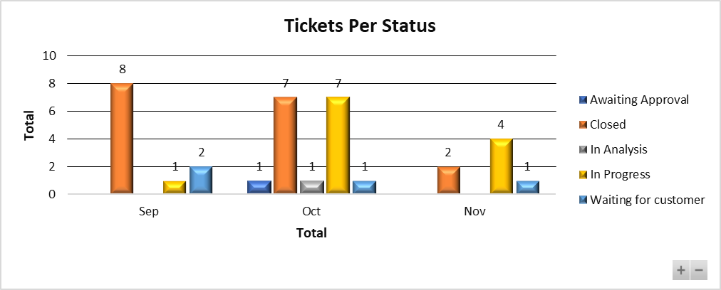

Tickets Awaiting Approval and Customer feedback

* SDWBSA-360 – Business will not go through with the change (To be closed)
* SDWBSA-382 – Error logs need to be sent to Sofico for further investigations
* SDWBSA-417 – Feedback is required to close the ticket (To be closed)
* SDWBSA-341 – Miles performance being tracked and solutioned as part of the M3 project (To be closed)

1. Ticket Severity Classification - YTD by month

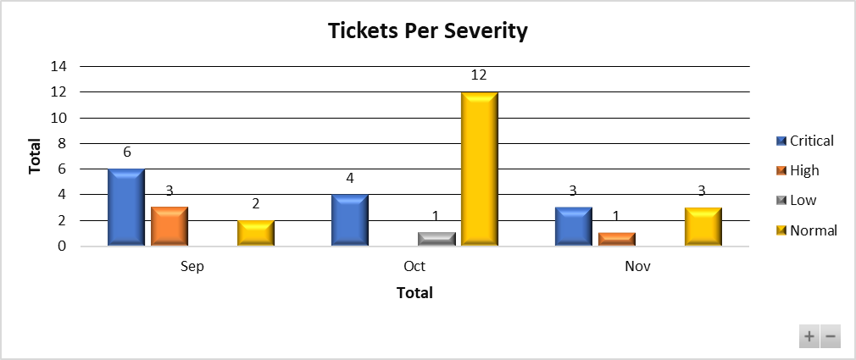

1. Ticket Volumes Changes vs Incidents - YTD by month

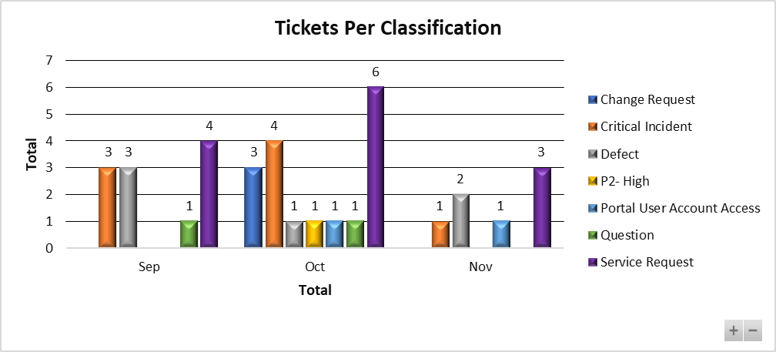

1. Invoices from Sofico Tracking – Due to be paid

|  |  |  |
| --- | --- | --- |
| **Reference No.** | **Description** | **Amount** |
|  | EP5 on 2022.2 20230522_2WK | R 22.686,94 |
|  | EP6 on 2022.2 20230522_2WK | R 22.686,94 |
| SDWBSA-312 | Everest Business Consulting | R 533.144,08 |
|  | Hosting MMP - Sep 2023 | R 172.380,98 |
|  | Hosting MMP - October 2023 | R 172.380,98 |
| SDWBSA-337 | Changes to debit order payment reference | R 310.916,23 |
| SDWBSA-388 | Business Consulting (September 2023 to December 2023) _WO008 | R 5.708.407,54 |
|  | Maintenance Fee (15/08/2023 - 31/12/2023) - Prorata M3 Contracts | R 1.419.813,63 |

# Quality Assurance

* Performance Testing – No performance testing conducted in October 2023.
* Security Testing – No security testing conducted in October 2023.
* Functional Testing – The QA team tested the 13 October 2023 Miles release.
* Miles Test Cases – There are 1112 test cases on ALM Quality Centre.

# HR

The headcount remains unchanged for the month of July.

**Headcount:**

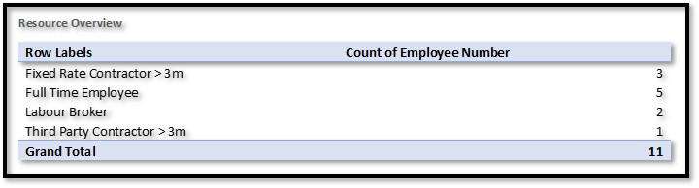

**Vacancies:**

* 1 x Technical Team Lead (Replacing Leeto Modutoane)
  + Status – interview stage

**Contract extension motivated for:**

* 1 x IT Platform Lead (Gordon Marriday)
  + Status – Contract extension motivation stage & pending Segment approval (not yet submitted to segment)

# IT Risk

# **1.** **FML IT Risk Overview – Executive Summary**

*The overall WesBank Fleet Management and Leasing IT Risk Profile remains Very* ***HIGH*** *and Increasing for the period under review (October 2023).*

*Key areas of concern remain around the post M3 go-live tickets spike around Miles’ functionality and data integrity negatively affecting the RT46 Contract linked penalties provisions, recurring finance (debit order run and ACB payments) issues in production,* *Performance issues within the Miles Environment, with number of instances noted within the RT46 call centre space, where various users experience timeouts on certain functions within the application. Issues with Critical Financial Job Failures and strengthening of the overall FML IT control environment through closing of the current open IT risk events and incidents and their root causes, with a Very High Impact to the FML Business. An IT Upliftment plan has been put in place to address identified gaps; however, the plan is being re-baselined pending headcount approval. The IT Release Strategy is also being developed to address the tickets backlog and deployment challenges that continue to negatively impact the IT Risk Profile.*

*Below is a view of risk rating and risk movement across the profile.*

|  |  |  |  |
| --- | --- | --- | --- |
| **Operational Risk Profile** | **August 2023** | **September 2023** | **October 2023** |
|  |  |  |  |

High-level View of the Current Open Items Influencing the FML IT Risk Profile:

**Audit findings:**

* There are currently nine (9) open FML IT Audit Findings being tracked in the month of October 2023.
* Of the nine (9) findings, three (3) findings are due at the end of October 2023; two (2) of the three (3) on track for the due date, while an extension request has been logged for one (1). The finding pertains to ‘Governance process not followed prior to deployment of the Miles system role matrix into production’ (GIA-582554).
* Three (3) out of the nine (9) findings are tracking for resolution by the end of November 2023; one on track for the due date while the other two are tracking for a possibility for extension, IT Risk in discussion with management for the request to be logged. The finding pertains to ‘Uniform Resource Locators (URLs) not secure – Miles Core’ (GIA-582343) and ‘User Access – Inappropriate system access granted to staff members’ (GIA-582555). Possible Extension Required, in discussion with management for the request to be logged. The finding is to be moved to business for tracking, as it is dependent on a business process change than an IT Change.
* The last three (3) findings are tracking for resolution in 2024; all on track for the due date.

**SDIs:**

* **New Self Disclosed Issue (SDI): Miles Credit Overview Screen Showing Excesses on Non-revolving Limit (Residual High Risk):**
* Business identified a risk where Miles is incorrectly calculating non-revolving limits which results to excesses when compared to CRO – refer to Annexure C for the detailed submission. ***FML Exco to ratify for Commercial CRO Manco approval.***

**Audit Extensions:**

* **Audit Extension Requests:** There was one extension request in October. See below!
* GIA-582554 - Governance process not followed prior to deployment of the Miles system role matrix into production. Finding due 2023/10/30 business require time 2024/03/31 to resolve. Extension request included in pack – refer to Annexure D for detail. ***FML Exco to ratify for Commercial CRO Manco approval.***

**Compliance:**

* ***FML IT Security Training Completion:***
* FML was seating at 99.21% overall for the four (4) open modules on Know-Be4 as at the end of October 2023.
* The Info security stats for FML is on track for all training modules referencing; (1) Realty Bytes: Ransom Gangs, (1) Spot the Bad Attachment and (1) Spot the Bad link. All modules are tracked above the acceptable threshold of 95%. The incomplete % is due to long leave.
* Overall FML compliance is impacted by the new module, Business Email Compromise that was rolled out in June with a deadline of 31 October. The 0.79% incomplete % was due to staff that was either on leave or recently terminated their employ with the bank.

**key Risk Indicators (KRIs):**

* Currently all IT Risk KRIs are tracking and reported at a WesBank level. FML specific KRIs still under development, engagements ongoing between FML IT, IT Risk and WesBank IT for FML specific KRIs to be defined in line with the critical SLA deliverables for the business unit. FML specific Cost Centres required for configuration into Open Pages to enable this change.

**Monitoring:**

* **FML Role Based Access Reviews on Miles:**
* Miles Look-up Tables Access Rights (RT46/SAPS): The change deployed in July for the look-up tables definitions and LUT type changes did not cater for the RT46/SAPS users. Therefore, a change is still required to the LUT types to include the three teams within RT46/SAPS Call centre. As an interim measure, a new LUT Type “Lookup Table Data Management” was created to be utilised by these teams specifically ‘Frontline’ as this team cannot use any of the existing 8 look-up table types in prod. The access to the table is granted on a need to have basis, with the line manager requesting access on behalf of their users and profiles actioning post approvals from business, IT and Risk being obtained.

* Audit Logs on Lookup Tables: Still tracking for resolution beyond the targeted date. A change for audit logs to all look-up table changes to be deployed in line with the approved FRS. Issue prioritized for resolution before the end of October 2023.

**Miles Stabilisation:**

* Stabilization of Miles remains a business priority and resolution of all tickets are underway via the various releases.
* Performance issues continue to be noted within the Miles Environment, with number of instances noted within the RT46 call centre space, where various users experience timeouts on certain functions within the application. A problem ticket has been raised to this effect (PRB0046248 – Miles hanging errors), issue under investigation and the ticket remains open until a permanent solution has been found.
* EPs continue to be deployed without performance testing performed on the patch prior to deployment (Resource limitation highlighted).
* Resources, prioritization, Emergency Patches failing upon QA testing leading to Eps not being deployed for the month as planned and the various code freezes (month-end freezes) in between impacts resolution of tickets that impact critical business operations.
* The plan is to close the M3 programme by 2023/11/30, pending business approval.
* There is increased focus between Project Management and Risk Management to review the Governance Health of the programme prior to closeout.
* An IT upliftment plan is being put together to deal with and address key gaps identified in the current operating model and supporting capabilities.

**IT Continuity**

* **Blackout Planning**: Planning for a complete electricity grid failure event is underway. Particular attention is being provided to critical business services in Rest of Africa regions and those that may be required to be kept online in support of government services (mainly in the FML environment); all other systems to be subject to graceful shutdown after the wind-down of business activity. The approach is in alignment the broader R&C resilience strategy as well as with planning expectations communicated by the South African Reserve Bank. The revised blackout plan is being reviewed along with the identification of critical staff required for ongoing system maintenance and graceful shutdown; with whom addendum contracting will be concluded. This is driven at a WesBank IT and Commercial Segment level.

* **DR Capability Risk**: Mitigation of key DR capability risks awaits completion of the remediation plan for the DR which has been defined, aligned to FNB strategic data centre planning and approved. Full implementation bears a dependency on the FNB Data Centre strategy flight plan, however the target implementation is anticipated by November 2023. Further implementation of the remediation plan will continue once the migration has completed, with detailed planning being outlined for the necessary remedial steps and establishment of a Red4 DR presence. This is also tracking at WesBank IT Risk level.

* **Lack of Miles High Availability (HA) capability:**

* HA capability for Miles was implemented as per approved architectural design, the capability has been noted as being inoperable after a Miles patch implementation in September 2022 which changed the infrastructure environment.
* In December 2022, the vendor (Sofico) recommended upgrading to the latest JBOSS version, however this did not resolve the issue and escalation to the vendor for root cause assessment and resolution continued. Sofico requested additional time to identify the cause of the issue which was then approved by FML IT.
* The issue compromises the ability to rapidly failover the application if one application cluster fails, however the disaster recovery capability for the system is still functional. The potential impact may include operational downtime outside defined business appetite.
* There is an interim strategy in place – manually cutting over Miles to RED3 in an event of availability issues however there may be a delay in the cut-over process due to the manual nature.

**Update:** Middle ware confirmed a dedicated server for HA on JBoos7.4, logical inclusion, tested and works with this version 7.4, to upgrade prod into 7.4 and include with the I&SS move. Target for March 2024, HTTP service prioritised for Nov/Dec, POC included. Manual cut-over and manually shut-down to move to Red3 if Miles were to go down.

**IT Risks - Top of Mind IT Risks:**

* **Miles Storage Capacity – Document Management (New High-Risk):** Miles is currently storing files in its internal storage server and is running out of capacity. This poses a risk of the system being unavailable. The interim solution is to archive documents to an external repository in line with record management practices targeted the move of Miles I&SS as a permanent solution, mitigating risk which is targeted for 2024/03/31. This risk is still tracked as High-Risk until interim controls are implemented.

* **Non-Production Data on Miles Being the Same as the Production Data Without Data Masking on the Non-Production Data:** The data that is seating on non-production Miles’s environments is a direct replica of the production environment with no security hardening and masking. Meaning the developers, QAs, testers and Engineers; even though they do not have success to production data, they can easily extract the same copy from non-prod as someone who has access to prod and do as they please with the data.

* **IT Resource Capacity Constraints - FML IT Not Being Able to Meet Business Demands with Current Resource Capacity and Skills:** There is currently high demand (number of Service Requests and incidents), with slow turnaround times on resolution. With Miles implementation into the WesBank Structure, efficient servicing of the business requires maturity in the approach to change management including the level of testing that goes into the fixes and patches. That level of maturity has not been achieved by the current IT structure.

* **Month-to-Month Critical Financial Jobs Failures:** There are a number of jobs that failed since the July 24th M3 (Miles Go-Live for RT46/SAPS Contract Base) namely the regular Debit Order Run Failures, ACB Payments Run Failures, Duplicate and Missing Invoices on MVP1, FleetActiv Monthly Billing Failures (INC 6179574) and Double Billing, FICS Transaction Export Failure, and consequently the FICS Trial Balance Failures due to data quality and integrity reasons post migration from auto-card to Miles.

* **FML IT Configuration and Development Team performing Application Support Duties** leading to inadequate access to production environment and production Data. This is due to limitation linked with the availability of the shared services resources for application support for Miles forcing the config an dev team to be assigned supporting tasks. There’s dependency on the IT Ops Resourcing Strategy and plan. Engagements ongoing to find a suitable long-term solution while selected resources within the config and dev teams will continue running some jobs for Miles and some of the support role being re-assigned into the Milles Application Support Officer.

* **Patches Deployed to Miles Production Environment Without any Performance Testing Performed and sometimes Limited Regression Testing.** This is due to a resourcing constraint within the QA and performance testing teams. There is also a challenge that comes with speed to market and delivery on projects and on BAU patch releases that sometimes do not allow the sufficient time required by the QA team to perform full regression testing. This is being addressed with the development of a release strategy by the FML CIO.

* **QA, SIT and UAT testing performed Parallel of Each Other -** Affecting and limiting the quality and value derived firm each testing especially regression testing whereby some fixes will be in UAT without sufficient regression testing performed.

* **Limited Internal Knowledgebase for Miles** with High Dependency on the Service Provider (SOFICO) and Contracted Technical Support Resources for all Patches and Solutions to IT Tickets with Majority of the technical resources that supports the system being contractors.

* **Critical Financial Jobs Failures:**
* **ACB Payment Failures** – Payments Run are currently executed manually. A fix from Sofico is ready that will force users to follow the correct process when adding order items in the work order, so that we may longer encounter missing contract cost centres. The fix was part of the Emergency Patch (EP5) that failed testing and was rejected by CAB for the initial target date of 13 October. This patch will be part of the now updated Patch (EP7) that is currently being tested by the FML QA team, targeted for deployment on the 13th of October we will resume payments automation again. Until then, recurring incidents of payment run failure are to be expected.

* **Debit Order Run Failures** – The Miles Direct Debit Order Load Report Job Ends with an Error: ‘No Standard Transaction Records Found on the Report’.

Resulted due to field character issues between Miles and Fintegrate. The root cause is linked to data issues. The fix for this issue was also part of the Emergency Patch (EP5) that failed testing and was rejected by CAB for the initial target date of 22 October. This patch will be part of the now updated Patch (EP7) that is currently being tested by the FML QA team, targeted for deployment on the 13th of October we will resume payments automation again once deployed. Until then, recurring incidents of debit order run failure are to be expected.

* **FleetActiv October Billing failure (INC 6179574) and Double Billing -** The billing run failed on the 20th of October 2023 as follows: Task Launcher returned error code: 2 running with user WESBANK\svc win automation. - This usually indicates that the connection to the DB failed. Solution: The FleetActiv Dev Team then ran the billing run manually by running the batch file from the CMD line and not using the Task Scheduler. This was a temporal solution while the issue is being investigated.

A subsequent issue was then noted on the 27th of October 2023 when the FML Finance team noticed that statements on fleet active for the internal accounts were billed for October rentals as well, showing double billing for the month of October 2023. The arrears were showing in + 180 days.

* **Duplicate and Missing Invoices on MVP1** - Issues found are as follows:

* **Missing Paid Transactions :**
* Issues within Miles technical integration, perceived to be duplicates on the receipt of the file, merchants that we were missing on the IDB because of merchants that were not loaded onto the Delta file. This resulted in customer invoice not including transactions paid to merchants.

* **Duplicate Transactions:**
* Issues within Miles operational business processes as well as technical integration issues resulted in work orders being duplicated though the integration between Miles and AutoCard .

* **Missing “In-Flight” Work Orders:**
* “In-Flight” transactions that have not been updated since migration into AOL which are used in various customer facing status reports.

**Resolution Timelines:**

Missing Paid Transactions: 01/11/2023

Duplicate Transactions: On Track – Deployment Scheduled for 27/10/2023.

Missing “In-Flight” Work Orders: On Track – Deployment Scheduled for 27/10/2023.

Error Handling: On-going, permanent solution under investigation.

* **ConnectMe – IT and Risk Onboarding Assessment Not Performed Upon Onboarding of the Connect Me Solution**
* Targeted solution will be replaced with RTMC which is a current solution used within the FirstRand Group. Further assessment underway.

* **Unsupported Technology – Legacy Systems:**
* FleetActiv is running on an unsupported operating System (Windows 2008 R2 Software). A hardware upgrade was recently performed on the application moving the system hardware to the 2019 version. The upgrade was performed on the 26th of October 2023. Notwithstanding the hardware upgrade, plans to decommission the application are in-progress.

# Security

* + Vulnerabilities: 4 Perimeter vulnerabilities (medium risk) exist relating to SSL certificates, affects servers used by FML that has not yet been addressed. 25 critical or high-risk network vulnerabilities were detected on the reporting period. The IT Operations team are investigating and a plan for remediation will be put in place. Due date to be determined once investigations has completed.
  + Unsupported Operating Systems: 2 out of support OS (Windows 2008 R2) remain within the FML environment that needs to be resolved. Plans are in place for the decommissioning of these servers – End October 2023.
  + Unsupported Databases: There are 10 unsupported databases remaining within the FML space (down from 10), most relating to minor version upgrades (unsupported version vs in supported database). In addition, several of these picked up are related to bin/install files not removed after upgrade and needs to be removed. The DB admins have logged this as a hygiene action to remediate.
  + Security Awareness training: Well, done to FML team, nearly all of the employees have completed all their training The latest statistics are:
* 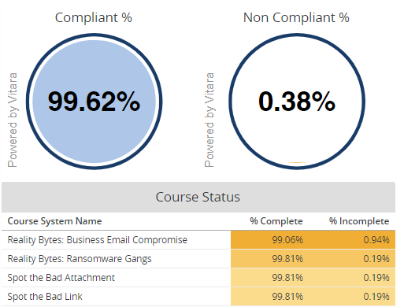
  + AD hygiene: Ongoing Active Directory hygiene is performed by the Ops team to align to group standards and to remediate any user or resource related issues in AD. At present, WesBank FML does not have any hygiene gaps in AD.
  + PAM: All system administrators are being enrolled into Beyond Trust – the Privileged Access Management System; this includes DBA (database administrators), operations teams, production support as well as system administrators (business and IT). The administrators will then have to use their privileged access booked out from the Beyond Trust system to perform any admin functions. Due date is for end of October 2023.

# **Finance**

## Financial Performance: FML YTD October FY24



**Commentary:**

**Staff Costs:** Staff costs is below budget by 9%. This is a result of 2 Vacancies in the area and 3 BAs budgeted for from July only transferring in from August. This is offset by one BA who transferred in but was not budgeted for and 1 resource is expected to be 100% recovered but is currently not recovering on M3.

**Attrition** cut relates to cuts loaded for expected natural attrition.

**Professional fees:** Professional fees budget relates to new managed service vacancy requested during budgets which has not yet been filled.

**Telecommunication:** Telecommunication costs relate to Telephone landline and 3G Data Costs. This is based on usage and is currently over budget.

**Charge-outs**: Charge-outs are slightly over budget by 2% mainly due to SAM Licenses due to an increased rate of return and increase in volumes of the Microsoft Office licenses, Cyber E-monitoring charge and service desk charge out.

**Project Recoveries:** Project Recoveries are below budget due to BA recoveries budgeted from July only coming in August; perm resources slightly under recovering and 2 resources budgeted for not recovering at all.

## Financial Performance: Project Recoveries YTD October FY24







## Financial Performance: Human Capital Information YTD Oct FY24





## Financial Performance: Allocated Costs YTD October FY24

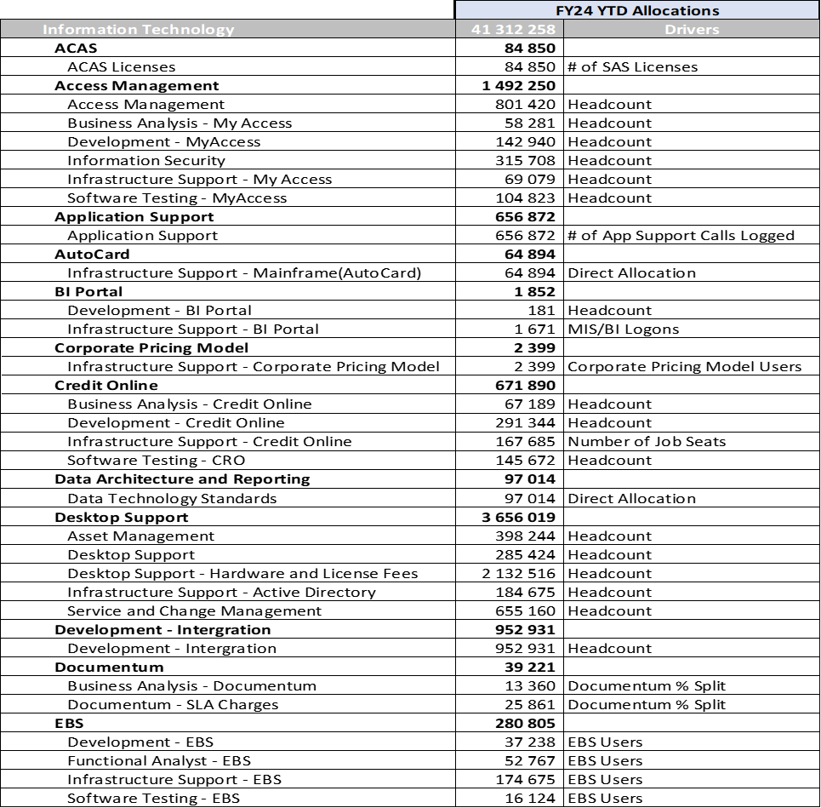

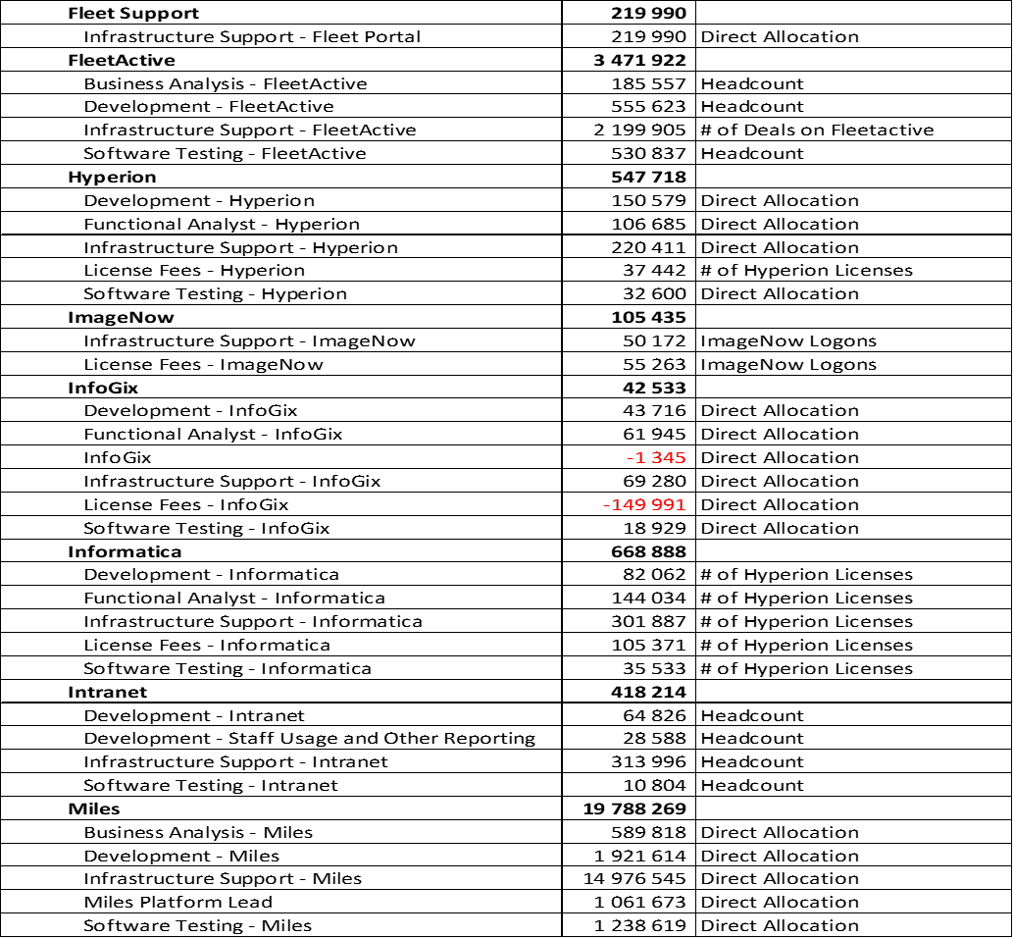

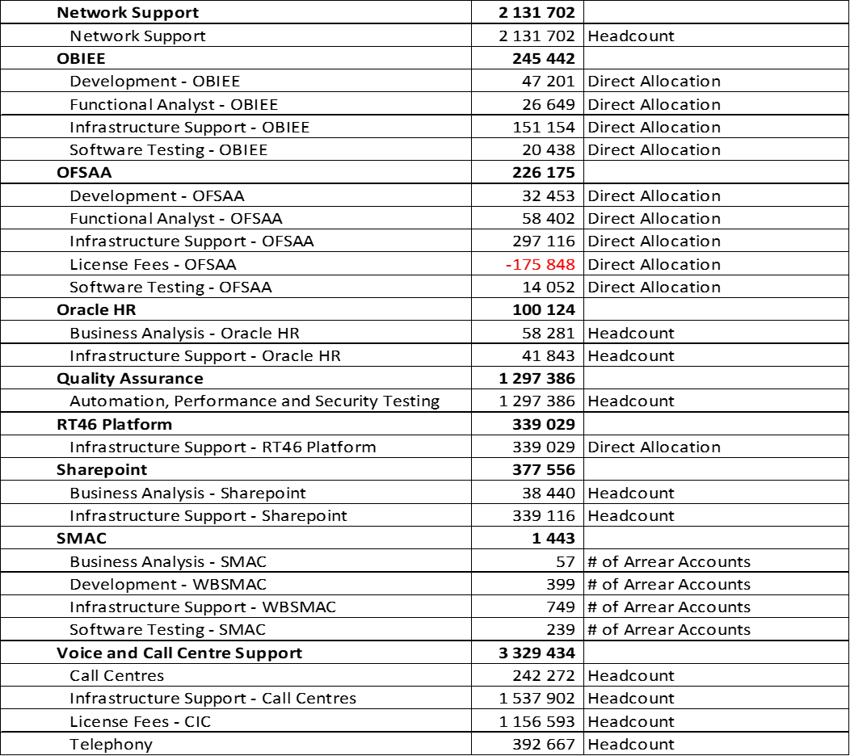

# General

Please note that a group DR test will be conducted between the 2nd and the 9th of September 2023.

* General environments freeze between 18th of August to 17th of September
* Production environment impact on 2nd and 9th of September
* Non-production environment impact between:
  + 1st of September and 5th of September
  + 8th of September and 12th of September

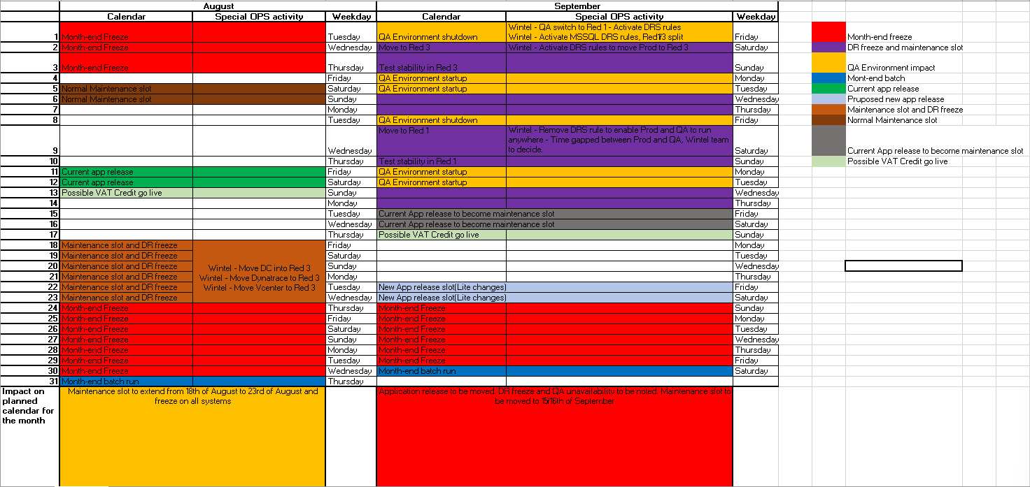

# Distribution

|  |
| --- |
| WesBank IT Exco |
| FML Exco |

Informational:

|  |
| --- |
| FML IT Leadership |